Analysis and Improvement of Fugitive Dust Regulations in Korean Construction Sites

Hyunjun Noh ¹, and Jungho Yu ²

¹Master Student, Department of Architecture Engineering, Kwangwoon University, Korea
²Professor, Department of Architecture Engineering, Kwangwoon University, Korea

Abstract
Because the seriousness of particulate matter (PM) is increasing along with public concern, it is necessary to strengthen the crackdown on fugitive dust at construction sites where the contribution to PM is high. In Korea, the only standard is the 'Standards for installation and necessary measures for suppressing fugitive dust generation', which covers the eleven emission processes proposed by Korea's Enforcement Regulations for the Clean Air Conservation Act. Korea’s regulations are based on the emissions process, which is connected with work places where fugitive dust emission is an issue, so the contents are insufficient and hard to link to the regulations. Regulation is required prior to strict crackdowns in order to manage fugitive dust in construction sites. These regulations are clear, specific and useful. This study analyzes the fugitive dust regulations and suggests measures for improvement.

Keywords: Regulations, Fugitive dust, Particulate matter, construction site, Clean Air Conservation Act.

Contact Author: Jung-ho Yu, Professor, Department of Architectural Engineering, Kwangwoon University,
01897, Seoul, Kore
e-mail: myazure@kw.ac.kr

Introduction

In light of the growing public interest in the environment, particulate matter is becoming an increasingly important issue. In recognition of the seriousness of particulate matter, the World Health Organization (WHO) proposed air quality guidelines for fine dust (PM10-2.5) in 1987, and the International Agency for Research on Cancer (IARC) designated particulate matter as a group-1 carcinogen with confirmed carcinogenic effects in humans. In Korea, since the introduction of the Total Suspended Particles (TSP) standard in 1983, the standard was changed to PM10 in 1995 and PM2.5 in 2015.
Particulate matter, which is an air pollutant, adversely affects not only environmental pollution but also the quality of life, causing damage to public health and discomfort in daily life. Fugitive dust comprises the largest portion of PM. Of all the complaints related to fugitive dust in the Seoul metropolitan area, 99.4% occur in construction projects. This shows that fugitive dust from construction work has the greatest influence on residents.
The Clean Air Conservation Act stipulates that construction sites must be in accordance with regulations for each size and type of building in terms of the management of scattered dust in construction, and proposes regulations for the prevention of fugitive dust. Local governments are conducting periodic inspections based on regulations, and taking administrative actions (e.g., improvement orders, fines, warnings, orders to implement measures, suspension of use). However, considering that the number of civil complaints related to fugitive dust is at a maximum, there is some doubt as to the effectiveness of the current fugitive dust management system and countermeasures.
One of the major causes of this problem is the ambiguity of the fugitive dust suppression regulations, particularly in their application to construction sites. In addition, there is no dedicated provision that uses construction terminology, even though construction site fugitive dust represents the largest portion of PM. This study analyzes the scattering control regulations on construction sites, and proposes some improvements.

Fugitive dust regulations on Korean construction sites

The regulation on fugitive dust at construction sites is based on Article 58-4 of the Enforcement Regulations of the Clean Air Conservation Act, 'Standards for installation and necessary measures for suppressing fugitive dust generation'. This includes eleven emission processes that generate fugitive dust and sets forth corresponding measures. In addition, if there is concern that a project may cause significant damage to the health and property of the inhabitants or the growth of plants and animals, stricter regulations may be enforced in the field, loading and unloading, and transportation items. But since the regulations are classified on the basis of performance work as opposed to various industrial fields, the terms are unclear and it is difficult to clearly apply the provisions. Especially, It is complicated and difficult to apply to construction activities that generate fugitive dust to the regulations. Therefore, regulations that clearly define and respond to construction activities are needed.

Table 1. 'Standards for restraining facility installation and necessary measures for suppressing fugitive dust generation.
Process | Note
Open Storage | Particulate material
Loading and Unloading | Particulate material
Transportation | Cement, coal, soil, feed, grain, scrap metal, wood
Transfer
Mining and Extraction | Blasting and preparation, excluding mine work
Grinding, Crushing | Applicable cement manufacturing, Excluding mine work
Field cutting
Field descaling
Field polishing
Field painting | Outdoor painting facility,  or products with a length of 100 m or more
Other processes | Building construction sites, civil works sites, and building dismantling

Improved fugitive dust regulations focused on construction

The United States provides standard guidelines and regulations under the EPA's Clean Air Act for the construction sector, but the guidelines for construction differ by federal and regional area. Among them, Antelope Valley Air Quality Management District (AVAQMD) developed the Air District Rule based on California’s Health & Safety Code. It includes administrative, legal, and practical procedures, and designates responsible persons for the construction project.
Referring to the above improvements, if the Korean government revises the regulations to reflect the specifics of the actual fugitive dust generated on Korean construction sites, more effective fugitive dust control can be expected. In ‘Study on the Actual Condition and Effect of Dust Scattering in Construction Field’, 215 employees were surveyed on a 5-point scale. They responded that among the total 8 kinds of work processes, site preparation work and earth work generated the most fugitive dust, and among the total 15 kinds of equipment, dump trucks, drills, breakers, bulldozers, and mobile cranes generated the most fugitive dust. In addition, six types of construction equipment (i.e., excavator, loader, forklift, bulldozer, crane, and roller) can be used only if they meet the EPA's strictest tier-4 emission regulations.
As a result of this analysis, the amendments to the regulations on fugitive dust in construction activities are summarized as follows.
- Clear definition of content related to construction activities;
- Requirements for reducing fugitive dust from construction processes; and
- Definition of work-related procedures to be conducted on construction projects.

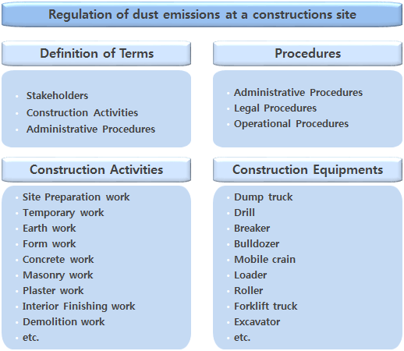
Fig.1. Amendment reflecting three improvements.

Conclusion

There are no specific legal regulations for the fugitive dust generated on construction sites except for the eleven processes provided by the Enforcement Regulations of the Clean Air Conservation Act. It is difficult to respond to the fugitive dust generation work of the construction work using only the current legal provisions. In January of 2017, the Ministry of Environment provided a Manual for Fugitive Dust Management, but it does not apply universally to all construction, and there is no legal enforcement. Due to the ambiguity of these provisions, it is difficult to effectively crack down, and it is unclear who is responsible for the fugitive dust control (Supreme Court Decision 8908, 2014). To resolve these problems, this study proposes construction regulations based on three major improvements. If the pollutant emission factor of Korea’s construction equipment is complemented and made more accurate in the future, it will be possible to revise regulations related to construction equipment items more accurately and in accordance with the actual situation.

References

- Antelope Valley Air Quality Management District(2011), Air District rule, Rule 403
- The Korea Ministry of Environment(2017), Manual for Fugitive Dust Management
- Enforcement Regulations of Korea Clean Air Conservation Act(2015), 'Standards for installation and necessary measures for suppressing fugitive dust generation, Article 58-4
- H.J. Yu., K.Y. Han., K.S. Kwak., J.S. Kim., K.Y. Yang(2004), Study on the Actual Condition and Effect of Dust Scattering in construction Field, Journal of The Korea Institute of Building Construction, pp109-115
- EPA(2015), Federal Environmental Requirements for Construction

